2023 Higher Level Physics Deferred Paper
1.
A student carried out a laboratory experiment to investigate the relationship between the force applied to a system of masses and the acceleration of the system.

Draw a labelled diagram of how the apparatus was arranged in this experiment.
ramp/air track, trolley, timer system, string & weights

- Using your diagram or otherwise, explain
  - what quantities need to be measured so that the acceleration can be calculated
initial & final velocity, displacement / time
  - how the student calculated the acceleration.
v² = u² +2as / v = u +at

- How did the student measure the applied force?
using weights
- How did the student ensure that the applied force was the only force accelerating the system?
set the slope of the track so that friction was balanced by acceleration due to gravity
cleaned the track / oiled the wheels of the trolley
- Why did the student ensure that the mass of the system was kept constant?
changing mass would introduce a third variable
- How did the student ensure that the mass of the system was kept constant?
masses transferred from the trolley to the pan
- Using the graph above, calculate the mass of the accelerated system in kilograms.
m = 0.532 kg
2.

A student carried out an experiment to measure the specific heat capacity of water. 61 g of water at 10 °C was placed in a container of negligible heat capacity. Energy E was supplied to heat the water and θ, the temperature which the water reached, was recorded. This was repeated a number of times with different values of E supplied to equal masses of water. The student was careful that the water had an initial temperature of 10 °C each time.
The data were recorded in the table below.

E (J) | 1273 | 2552 | 3823 | 5107 | 6376 | 7642
θ (⁰C) | 15 | 20 | 25 | 30 | 35 | 40

- How could the energy have been supplied to the water?
current carrying coil / hot copper pellets
- Describe two precautions that the student should have taken to ensure that θ was measured accurately.
Stir the water / wait until highest temperature is reached
- Describe how the container of water might have been insulated.
lagging / lid

- The student used a container of negligible heat capacity.
What is the significance of the fact that the container had negligible heat capacity?
It can be ignored in the calculation
- Using the data provided, draw a suitable graph on graph paper of E against Δθ, the change in temperature of the water.
- Calculate the slope of your graph.
m = 254.8 J K⁻¹
- Use your slope to find the specific heat capacity of water.
c = 4176.6 J kg⁻¹ K⁻¹

3.

A student was given a box that contained both converging lenses and diverging lenses.
The teacher asked the student to determine f, the focal length of one of the converging lenses.
The student chose a converging lens from the box. First, an approximate value of its focal length was measured. Then a suitable object was used to form an image on a screen and the object distance u and the image distance v were measured. This process was repeated for different values of u and v, which were recorded in the table below.
u (mm) | 150 | 200 | 250 | 300
v (mm) | 169 | 135 | 119 | 108

- Why would the method described for this experiment not work for a diverging lens?
image cannot be formed on a screen / only a virtual image is formed
- How did the student determine which lens was a converging lens?
shape / check if it formed a magnified/inverted/real image
- How did the student find an approximate value for the focal length?
focus image of a distant object on a screen
measure the distance from the lens to the screen
- Draw a labelled diagram of how the apparatus was set up to measure u and v.
Label the distances u and v on your diagram.
object, lens, screen, correct arrangement
u = object to lens
v = lens to the screen

- Describe two precautions that the student should have taken to ensure that v was measured accurately.
avoid error of parallax / measure to/from centre of the lens
- Use all the data provided to calculate an average value for f.
f = 79.5, 80.6, 80.6, 79.4 mm
f_{average} = 80.0 mm

4.

A student investigated the relationship between the resistance R of a piece of metal wire and its temperature θ. The data were recorded in the table below.
θ (⁰C) | 10 | 20 | 30 | 40 | 50 | 60
R (Ω) | 0.188 | 0.194 | 0.203 | 0.209 | 0.213 | 0.220

- Draw a labelled diagram of how the apparatus was arranged in this experiment.
Heat source, wire, thermometer
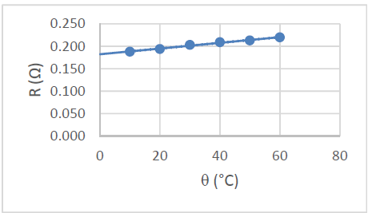
- Draw a suitable graph on graph paper to show the relationship between R and θ.

The student carried out research to identify the material that the wire is made from and found the values for the resistivity ρ of various materials at a temperature of 300 K, as shown below.
material | aluminium | constantan | copper | nichrome | steel | tin
ρ (nΩ m) | 26.5 | 490 | 17.0 | 120 | 150 | 110

- Convert 300 K to °C.
273.15 °C
- Use your graph to find the resistance of the wire at 300 K.
θ = 26.85 °C
- The wire is found to have a length of 0.221 m and a diameter of 0.46 mm.
R = 0.199 mΩ

- Name a suitable device that could have been used to measure the diameter of the wire.
micrometer / digital / vernier callipers
- Use the data to calculate the resistivity of the wire at 300 K.
resistivity formula
area formula
ρ = 1.49 x 10⁻⁷ Ω m
- Identify the material that the wire is made from.
Steel

5.

A student investigated the variation of current I with voltage V for a semiconductor diode in forward bias. The student set up a suitable circuit and recorded the data shown in the table below.

V (V) | 0 | 0.25 | 0.5 | 0.55 | 0.6 | 0.65 | 0.7
I (mA) | 0 | 0.04 | 0.21 | 0.44 | 1.5 | 4.48 | 14.24

- Draw a circuit diagram for this experiment.
diode in forward bias, voltage source, ammeter in series, voltmeter in parallel
- How did the student vary the voltage?
rheostat was adjusted
- How did the student ensure that the diode did not overheat?
protective resistor put in series with it
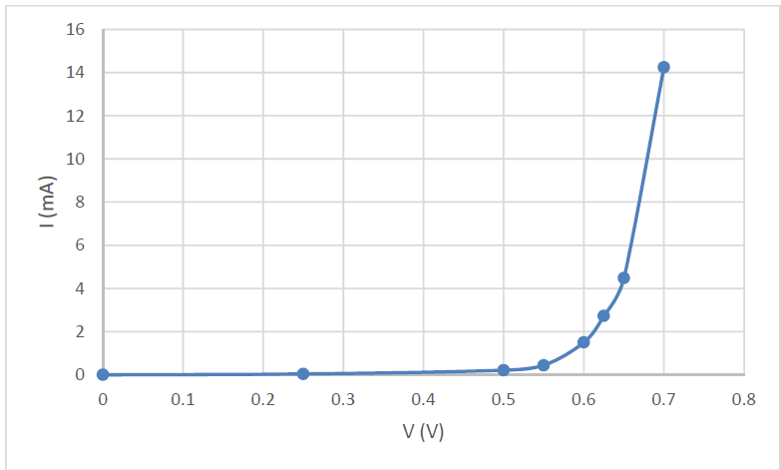
- Draw a suitable graph on graph paper to show the variation of I with V for the semiconductor diode.
Draw a suitable graph on graph paper to show the variation of I with V for the semiconductor diode.

- Identify the junction voltage of the diode.
V ≈ 0.55 V
- The student was then asked to investigate the variation of I with V for a semiconductor diode in reverse bias. What changes should have been made to the circuit for a diode in reverse bias?
Reverse the diode/battery connections / use a microammeter / put the voltmeter across only the diode

6. Answer any eight of the following parts, (a), (b), (c), etc.
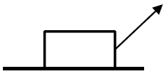  A child drags a box across a horizontal floor with a force of 44 N applied at 47° to the horizontal. The friction between the box and the floor is 20.5 N.  Calculate the net horizontal force on the box. | - F_{Horizontal} = 44cos60 N = 22 N  F_{Net} = 22 – 20.5 = 1.5 N in the direction of the table
Write an expression for the acceleration a of a body oscillating at the end of a spring in terms of the mass m of the body, the spring constant k, and the displacement s of the body from its equilibrium position. | F = ma / F = -ks / a = -ω²s  ma = ks  ω = 􀶧 􀯞
When exercising, an athlete loses body heat through perspiration at a rate of 300 W.  Calculate the mass of perspiration that needs to be evaporated from the athlete each minute to account for this heat loss.  latent heat of vaporisation for perspiration = 2426 kJ kg^{–1} | Heat loss for 90 minutes = 1.62 x 10⁶ (J)  E = ml  mass per minute = 0.0074 kg
A stretched string vibrates at a fundamental frequency of 205 Hz when the tension applied is 5 N. Calculate the fundamental frequency of the string when the tension applied is 10 N. | 𝑓 ∝ √𝑇  𝑓􀯡􀯘􀯪 = √2 × 205 = 290 𝐻𝑧
A person holds a curved metal spoon at arm’s length and rotates it slowly. On one side of the spoon the image seen is inverted and on the other side the image is upright. Explain why. | (econcave side always gives an inverted image as long as the object is outside the focal length  convex side always gives an upright image
The refractive index of a diamond is 2.41. Calculate its critical angle. | n = 􀬵  C = 24.4◦
Explain the principle of operation of polaroid sunglasses and how they help the wearer. | polarisation / vibrations of a transverse wave restricted to vibrate in one plane only  reflection polarises light which can be blocked by correctly oriented polaroids in the  sunglasses
State the colours of (i) the live wire, (ii) the neutral wire and (iii) the earth wire in a plug.  (i) live – brown | neutral – blue  earth – yellow & green  arrangement with fuse
Sketch a graph to show how current varies with the voltage applied across the vacuum in a cathode ray tube. | (j) axes labelled  shape
Explain why a balloon that has been rubbed vigorously on a woolly jumper can stick to a wall. | ) balloon becomes charged by friction  like charges in the wall are repelled  balloon sticks to unlike charges left closest to the surface of the wall
Calculate the maximum moment of the couple in a basic d.c. motor when a current of 0.13 A flows through a square piece of wire of side 5 cm in a magnetic field of 0.22 mT. | F = BIl / T = Fd  F = 1.43 x 10–3 (N)  T = 7.15 x 10–5 Nm
) Explain why the existence of the neutrino was first proposed. | to conserve energy / to conserve momentum  in beta decay
What is an electromagnetic relay? State one use of an electromagnetic relay. | an electrical switch operated by an electromagnet  example: car ignition system

7.

- State Archimedes’ principle.
When an object is immersed in a fluid the upthrust it experiences is equal to the weight of the displaced fluid.

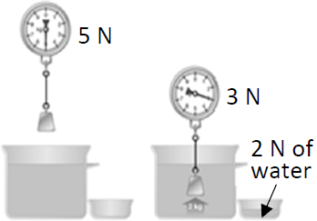
- Describe a laboratory experiment to demonstrate Archimedes’ principle.
Diagram: Object in a fluid, overflow can, electronic/newton balance,
Method: Find weight of object in air & weight in water
Find weight of fluid displaced
Result: (Weight of object in air – Weight of object in water) = Weight of fluid displaced

- Steel is denser than water. A steel bar sinks when it is placed in water. Explain why.
The mass of the volume of water displaced is less than the mass of the steel bar, so the gravitational force of attraction between the Earth and the steel bar is greater than the gravitational force of attraction between the Earth and the displaced water, so the steel bar sinks and as a result the displaced water rises.
OR you could go with the marking scheme:
The weight of the fluid displaced by the steel is less than the upthrust / weight of the steel

- A boat which is made mostly of steel floats in water. Explain why.
Because of its shape the average density of the ship includes the air it contains making it less dense than water.
Or: the weight of the fluid displaced by the boat equals the weight of the boat

- Calculate the density of air at the surface of the sea.
Mass = 7.75 g = 0.007 kg
There are 1000 grams in one kilogram.
So to convert from grams to kilograms we need to divide the mass by 1000.
Therefore the mass is 7.75 g = 0.007 kg = 7.75 ×10⁻³ kg

Volume = 6000 cm³.
There are one million centimetres cubed in a metre cubed (1 million cm³ in one m³).
So to convert from centimetres cubed to metre cubed we need to divide the volume by 1000000.
Therefore the volume is 0.006 m³ = 6 ×10⁻³ m³.

$Density=\frac{mass}{volume}$ $Density=\frac{{7.75×10}^{-3}}{{6×10}^{-3}}$ Density = 1.29 kg m⁻³
Why not simply leave the units in g and cm³? The short answer is that we could do so, in which case our answer would be
$Density=\frac{7.75}{6}$ = 1.29 g cm⁻³.
Both formats would result in full marks for this section (assuming that you have the correct unit written down beside the number.

However in the next section we will need to multiply our answer for density by other variables therefore all quantities needs to be in S.I. units, which in the case of density is kg m⁻³.

It is dragged down to the sea floor at a depth of 37 m.

Calculate the total pressure acting on the balloon when it is at a depth of 37 m.
To calculate the total pressure we need to add the atmospheric pressure to the pressure associated with being under water.
Pressure_{total} = Pressure_{atm} + ρgh
= 101300 + 372752.8
= 101300 + (1028)(9.8)(37)
= 101300 + 372752.8
= 474052.8 Pa

- State Boyle’s law.
Pressure is inversely proportional to volume for a fixed mass of gas at constant temperature
- Calculate the density of the air in the balloon at a depth of 37 m.
We know the mass of the air at a depth of 37 m (7.75 grams, and this doesn’t change) so to calculate the density of the air in the balloon at that depth we need to find the volume of that amount or air and then use $ρ=\frac{m}{v}$ to find the volume.

To calculate the volume of air at depth of 37 m we go back to Boyle’s law: p₁v₁ = p₂v₂
p₁ = pressure of the air at the surface = atmospheric pressure = 101.3 kPa = 101300 Pa
v₁ = volume of the air at the surface = 6000 cm³ = ${6×10}^{-3}$ m³ = 0.006 m³.
p₂ = pressure of the air a depth of 37 m = 474052.8 Pa (we just calculated this in the previous question).
v₂ = ?

p₁v₁ = p₂v₂ (101300)(0.006) = (474052.8)(v₂) v₂ = ${1.282 ×10}^{-3}$ m³.

$Density=\frac{{7.75×10}^{-3}}{{1.282 ×10}^{-3}}$ Density = 6.05 kg m⁻³

We are looking for density so again we can use units of kg m⁻³ or g cm⁻³.
If we had used grams and cm our answer would be 0.00605 g cm⁻³.

- Draw a force diagram to show the forces acting on the balloon as it rises through the water.
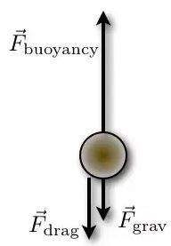
See diagram.

The drag force represents the force of friction which acts against the balloon ascending through the water.
Because the balloon is rising upwards the upward force must be equal to or greater than the sum of the downward forces. Therefore the upward arrow needs to be as long as or longer than the other two lengths added together.

8.

X‐rays and visible light are both part of the electromagnetic spectrum.
- What is the electromagnetic spectrum?
It is the full range of electromagnetic radiation divided by frequency/wavelength.
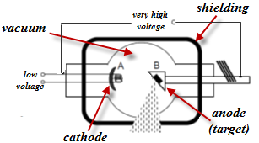
- Draw a labelled diagram of an X‐ray tube.
high voltage, heat source, cathode, anode, target, vacuuum.

- The working voltage of an X‐ray tube is 65 kV.
Calculate the maximum energy of the X‐rays that can be produced in this X‐ray tube.
Q = charge on an electron = 6 × 10⁻¹⁹ C
V = 65 × 10³ V

W = QV
W = (1.6 × 10⁻¹⁹)(65 × 10³)
W = 1.04 x 10^{–14} J
- What property of X‐rays makes them suitable for use in diagnosing a broken bone?
Penetrating ability
Helium was first observed by the French astronomer Jules Janssen in 1868.
He made careful measurements of the line emission spectrum from the Sun using a recent invention, the spectrometer. He observed a bright yellow line whose wavelength did not match any known element found on Earth at that time. It was later found to belong to the spectrum of helium.
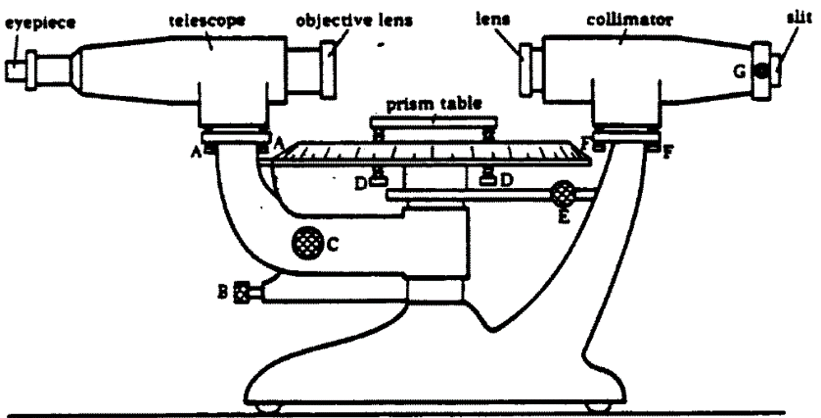
- Draw a labelled diagram of a spectrometer.
telescope, collimator, slit, table, scale

- State three adjustments that should be made when setting up a spectrometer.
Focus the telescope to accept parallel rays
Adjust the length of the collimator
Adjust the width of the slit
Level the table
Focus cross hairs

- Calculate the wavelength of the yellow light.
d = $\frac{1}{600000}$ = 1.67 × 10⁻⁶ m

In the equation nλ = d sin θ, θ represents the angle between the straight through position and the bright line. In this case we are given the angle 89.67⁰ but we are told that this is the angle between the two second order images. Therefore we need to divide this by 2. Therefore θ = 89.67⁰

n = 2
nλ = d sin θ λ = $\frac{d \sin{ }}{n}$ = $\frac{(1.67 × {10}^{-6})(sin{44.835) }}{2}$ λ = 588× 10⁻⁹ m.

- Explain why this diffraction grating is not suitable for use with X‐rays.
width of the slits is too big / wavelength of X-rays too short

9.

- State the law of radioactive decay.
Activity is proportional to the number of nuclei present
- What is meant by the term half‐life?
time taken for half the nuclei present in a radioactive sample to decay

- Name the type of radiation that travels in a straight line in the magnetic field.
gamma radiation
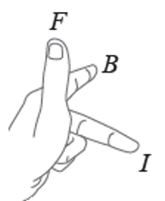
Justify your answer.
The radiation didn’t deflect in the magnetic field so must have no charge, and gamma radiation is the only radiation that has no charge.
- Use Fleming's left‐hand rule to determine the direction of the magnetic field.
The alpha radiation is positively charged so moves in the same direction as conventional current (opposite in direction to electrons). So working off the information in the question, our current is to the right while the force is upwards, therefore the magnetic field must be into the page, similar to the orientation of the hand in the diagram.

is moving upward which is the same direction that con

- Explain the term isotope.
Atoms with equal numbers of protons but a different number of neutrons
OR Atoms with same atomic number but different mass number

- Write a nuclear equation for the decay of uranium–235.
$${}_{92}^{235}U →{}_{2}^{4}{He+ {}_{90}^{231}{Th}}$$

- A sample of uranium–235 containing 7.69 x 10¹⁵ atoms has an activity of 0.24 Bq.
Calculate the half‐life of uranium–235.

N = 7.69 x 10¹⁵ atoms
A = 0.24 Bq.
A = λN λ =$\frac{A}{N}$ = $\frac{0.24}{7.69 × {10}^{15}}$ = 3.12 x 10⁻¹⁷

$T_{\frac{1}{2}}$ = $\frac{\ln{2}}{λ}$ $T_{\frac{1}{2}}$ = $\frac{0.693}{3.12×{10}^{-17}}$

$T_{1/2}={2.22×10}^{16}$ s

A sample of uranium–235 was trapped inside a crystal many millions of years ago.
The sample is analysed to estimate how many half‐lives have passed since the uranium was trapped.
The sample is found to have 1.5625 % of the original sample of uranium–235 remaining.

- Calculate how many half‐lives have passed since the uranium was trapped in the crystal.
1.5625 % = 1/64 and the sequence for half-lives is ½, ¼, 1/8, 1/16, 1/32, 1/64
So 6 half lives have passed.
- How many years ago was the uranium trapped in the crystal?
6 half lives = 6 × (${2.22×10}^{16}$ s) = ${1.332×10}^{17}$ s.
Now we need to convert this to seconds by dividing by the number of seconds in a year.
Answer: 4.23 x 10⁹ years

10.

Many electronic devices use direct current and relatively low voltages. However the current coming to our homes and businesses is a 50 Hz alternating current at a voltage of 230 V.
Electric current can be shown to have a magnetic effect.
- State the two other effects of an electric current.
heating, chemical
- Describe a laboratory experiment to demonstrate the magnetic effect of an electric current.
Method: Wrap copper wire around an iron nail and connect both ends of the wire to a 9 Volt battery.
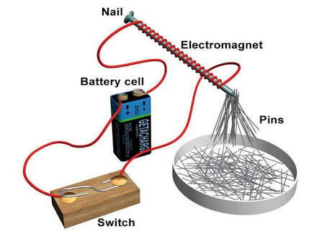
Result: The nail can be used to pick up metal paper clips when the circuit is complete.
- What is meant by voltage?
Work done per unit charge
- Calculate the maximum voltage of a 230 V alternating source.
V_{rms} = 230 V
V_{rms} = $\frac{V_{max}}{\sqrt{2}}$ 230 = $\frac{V_{max}}{\sqrt{2}}$ V_{max} = (√2)(230) = 325 V
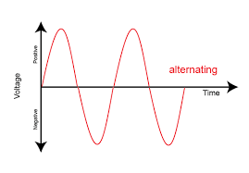
- An oscilloscope may be used to show alternating voltage.
Draw a diagram to show how alternating voltage is displayed on the screen of an oscilloscope.
axes labelled
correct shape

Many electronic devices use a charger to charge a battery which supplies the low voltages required.
One type of charger steps the alternating voltage down using a transformer.
- Explain the operation of a transformer.
Transformers operate on the principle of mutual induction, which is the process of inducing a voltage in a coil by changing the current in another coil.
- A transformer with a primary coil of 200 turns has an input voltage of 230 V. Calculate how many turns are needed in the secondary coil to give an output voltage of 5.75 V.
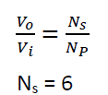

Some newer chargers make use of an electronic circuit to increase the frequency of the voltage.
This means chargers are not as big and heavy as they once were.
A coil of wire of area 0.42 cm² with 80 turns is placed in a magnetic field with magnetic flux density changing at a frequency of 127 kHz.
- Calculate the voltage induced in the coil as the magnetic flux density changes from a maximum of +2.6 mT to a minimum of –2.6 mT.
Area 0.42 cm² = ${0.42×10}^{-4}$ m².
B = ${2.6×10}^{-3}$ T
𝜙 = 𝐵𝐴 = ${(2.6×10}^{-3})({0.42×10}^{-4})$ =

Time taken.
Frequency = 127 kHz = 127000 Hz.
$T=\frac{1}{f}=\frac{1}{127000}$ = ${7.87×10}^{-6}$ s

Change of flux = ${(+2.6×10}^{-3})– {(-2.6×10}^{-3})$
Induced emf = $\left(N\right)[\frac{final flux – initial flux}{time taken}]$ = $\left(N\right)[\frac{{(+2.6×10}^{-3})– {(-2.6×10}^{-3})}{time taken}]$ = $\left(80\right)[\frac{ {5.2×10}^{-3}}{{7.87×10}^{-6}}]$

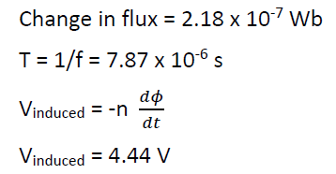
Change in flux = 2.18 x 10⁻⁷ Wb

11.

John Tyndall from Leighlinbridge, Carlow was born in 1820. His major scientific interest was the interaction of light with matter. Among his many achievements was his discovery of the Tyndall effect, which led to the explanation of why the sky is blue. He realised that the colour of the sky is related to the scattering of light from the Sun by particles in the atmosphere.
- Name the colour in the spectrum of white light that has the longest wavelength.
Red
- Light from the Sun can give rise to a rainbow.
State two conditions necessary for an observer to see a rainbow.
You need sunlight
You need rain(drops). Well you do!
You need to have the sun behind you and the rain in front of you.
- The distance between the Sun and the Earth is often given in astronomical units (au).
1 au = 1.496 × 10¹¹ m.
At a particular time of the year, the distance between the Sun and the Earth is 1.011 au.
Calculate, in minutes, the time it takes for light to travel from the Sun to the Earth at that time of the year.
1 au = 1.496 × 10¹¹ m.
Distance s = 1.011 au = (1.496 × 10¹¹)(1.011) = 1.512 x 10¹¹ m
Speed = speed of light = ${3×10}^{8}$ m s⁻¹.

$v=\frac{s}{t}$ $t=\frac{s}{v}$ = $\frac{{1.512×10}^{11}}{{3×10}^{8}}$ = t = 8.41 min

The Sun is often described as the primary source of energy for the Earth. The Sun’s energy comes from nuclear fusion reactions. One of the main fusion reactions is described by the following nuclear equation:
$$H_{1}^{2}+H_{1}^{1}→{He}_{2}^{3}$$

- Calculate the energy released during this reaction.
See page 83 of log tables to get masses of the nuclei in terms of atomic mass units (u).
Then jump to page 47 to convert from atomic mass units to kg: 1 u = 1.660 5402 × 10⁻²⁷kg
Pick your own adjective to describe this logic.
$${}_{1}^{2}H + {}_{1}^{1}{H → {}_{2}^{3}{He}} +Energy$$

2.014102 + 3.016049 → 4.002603 + 1.008672 + energy
5.030151 → 5.011275 + energy
Change in mass = 0.018875 u
1 u = 1.660 5402 × 10⁻²⁷kg
0.018875 u = 3.1344 × 10⁻²⁹ kg

E = mc² = (3.1344 × 10⁻²⁹)(3 × 10⁸)² = 2.82096 × 10⁻¹² J

E = mc²
m_{difference} = 9.79 x 10³⁰ kg
E = 8.8 x 10⁻¹³ J

- As well as by direct heating from the Sun, the Earth can also be heated due to the greenhouse effect.
Explain how the greenhouse effect heats the Earth.
Radiation coming from the sun is high energy / short wavelength and travels straight through the atmosphere.
Radiation reradiated from the Earth is lower energy therefore longer wavelength and gases in the atmosphere can reflect this radiation back to the Earth.

- The greenhouse effect has both positive and negative consequences for human life on Earth.
Explain why.
The Earth would be too cold for humans without it
In a few years it may result in the extinction of the human species. So there’s that.

- Calculate the energy of a photon that has a wavelength of 2 μm.
λ =2 μm $={2×10}^{-6}$ m
$c=fλ$ $f=\frac{c}{λ}$ $f=\frac{{3×10}^{8}}{{2×10}^{-6}}$ = 1.5 x 10¹⁴ Hz

h = 6.6 × 10⁻³⁴
E = hf = (6.6 × 10⁻³⁴)(1.5 x 10¹⁴) = 9.93 x 10^{–20} J
- What phenomenon allows light to travel in an optical fibre without escaping?
Total internal reflection

12.

Answer either part (a) or part (b).

(a)
Atmospheric particle physics is a major field of research. Gamma radiation from deep space creates electron‐positron pairs in the Earth’s atmosphere.
- What is a positron?
It is an anti-electron (a particle with the same mass as an electron but the opposite charge).
- Name a detector suitable for detecting gamma radiation and describe the principle of its operation.
sold state detector / Geiger Muller tube(6)
- Write an equation to represent the creation of an electron‐positron pair by gamma radiation.
γ → e⁻ + e⁺ or hf = e⁻ + e⁺
- Electrons and positrons are both leptons. What is a lepton?
It is a fundamental particle which does not feel the strong nuclear force
Scientists also investigate high energy collisions using circular accelerators at CERN.
Two protons, each with kinetic energy of 6.8 TeV, and travelling in opposite directions are collided together. After the collision various new particles are detected, as well as the two protons.

- Calculate the maximum total mass these new particles can have.

The maximum that can be created would occur if all of the kinetic energy was converted into mass.
Total energy = 6.8 TeV
T = Tera = × 10¹²
1 eV = 1.6 × 10⁻¹⁹ Joules
6.8 TeV = (6.8 × 10¹²) (1.6 × 10⁻¹⁹) = 6.4× 10⁻¹⁰ joules

E = mc²  $m=\frac{E}{c^{2}}= \frac{6.4 ×{10}^{-10}}{{(2.9979 × 10}^{8)2}}$  m = 7.121 × 10⁻²⁷ kg

===================================

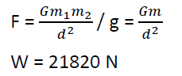
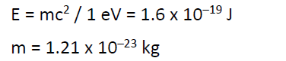

E = mc² / 1 eV = 1.6 x 10^{–19} J
m = 1.21 x 10^{–23} kg
============================================
Two of the particles that have been detected after high energy collisions are the sigma particle and the kaon.
- A particular sigma particle is made of an up quark, a down quark and a strange quark.
  - What type of hadron is this sigma particle?
baryon

  - What charge does this sigma particle have?
neutral

- A particular kaon is made of a down quark and an anti‐strange quark.
  - What type of hadron is this kaon?
meson
  - What charge does this kaon have?
neutral

Engineers at CERN are planning to build a new circular accelerator with a greater radius.
In a circular accelerator a large magnetic field of flux density B is used to keep a particle of charge q and mass m travelling in a circle of radius r.
- Write an expression for the tangential velocity v of the particle in terms of B, q, m and r.
Expression for force on a particle moving in a circle = Force on a particle in a magnetic field.$$\frac{mv^{2}}{r}=Bqv$$
Cancel one v on both sides and multiply both sides by r to get rid of the r on the left hand side.
⇒ mv = Bqr ⇒ v = Bqr/m

- Suggest a reason why engineers are planning to build a particle accelerator with a greater radius.
Velocity is proportional to the radius.

(b)

The semiconductor industry has grown to become one of the most important industries in modern society.
The development of semiconductors and integrated electronic circuits has led to a range of new devices which have changed the way people live.
- What is a semiconductor?

- Sketch the graph to show the variation of resistance with temperature for a semiconductor thermistor.

Rectification is an important process in modern electronics.
- A semiconductor diode can be used as a half‐wave rectifier.
Explain the term ‘halfwave rectifier’.
- A bridge rectifier can provide full‐wave rectification. Draw the circuit diagram of a bridge rectifier.
- What device can be used to smooth the current from a bridge rectifier?

A rectifier can be used to produce the direct current needed by a transistor.
- Describe with the aid of a labelled diagram the basic structure of a bi‐polar transistor.
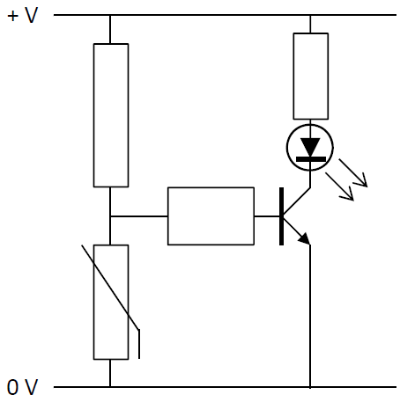
- The diagram below shows a thermistor used in a transistor circuit. Explain what happens in the circuit when the thermistor is kept at a low temperature.
- Logic gates are the basic building blocks of digital electronic circuits.
Draw a circuit diagram to show how a transistor can be used to make a NOT gate.

(ix) Draw the truth table for a NOT gate

13.

Read the following passage and answer the accompanying questions.
Almost any time physicists announce that they’ve discovered a new particle what they’ve actually spotted is resonance. Resonance is at the heart of things as diverse as music, nuclear fusion in dying stars, and even the existence of subatomic particles.
A parent pushing a child on a playground swing is a familiar example of resonance. Another example is when a singer shatters a glass with a sustained note. For a flute, there are specific resonant frequencies of sound waves that exactly fit inside the cylindrical shape.
In 1925, Erwin Schrödinger derived an equation for the hydrogen atom whose solutions are waves oscillating at a set of natural frequencies. Quantum theory revealed that the structure of atoms, no less than the structure of symphonies, is intimately tied to resonance. Electrons bound to atoms are a little like sound waves trapped inside flutes.
Quantum theory also showed us that light, which had been thought of as an electromagnetic wave, sometimes behaves like a particle, a photon. Meanwhile, matter‐particles such as electrons can exhibit wave‐like behaviour.
Resonance is also critical to nuclear fusion reactions. The most famous of these nuclear resonances enables the fusion of three identical helium nuclei into one carbon nucleus. Without this, stars would not be capable of producing carbon, and life as we know it would not be possible.
Adapted from: https://www.quantamagazine.org/how‐the‐physics‐of‐resonance‐shapes‐reality‐20220126/

- What is meant by resonance?
transfer of energy between two bodies with the same natural frequencies
- Describe a laboratory experiment to demonstrate resonance.
apparatus/diagram
method
result
- The motion of a playground swing can be thought of as a simple pendulum undergoing simple harmonic motion. Calculate the resonant frequency of a swing of length 1.5 m.
𝑇 = 2𝜋􀶧􀯟
􀯚 = 2.46 (𝑠)
f = 0.41 Hz
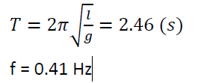
- A flute acts as a tube open at both ends.
Draw a labelled diagram to show the standing wave, vibrating at its fundamental frequency, produced in a flute.
two antinodes
one node
- A drinking glass can be modelled as a cylindrical pipe of length 15 cm that is closed at one end.
Calculate the fundamental frequency that would cause the glass to resonate and possibly even shatter.
λ = 0.6
c = f λ
f = 572 Hz
- Einstein’s explanation of the photoelectric effect depends on the concept of light behaving as photons. Outline Einstein’s explanation of the photoelectric effect.
one photon gives all its energy to one electron
if photon energy is greater than the work function, electron is emitted with kinetic energy
if photon energy is less than the work function, electron is not emitted
- At the start of the 20th century, both Niels Bohr and Erwin Schrödinger developed their models of the atom. Describe the Bohr model of the atom. (A labelled diagram may help your answer.)
electrons orbit a positive nucleus
electrons are only allowed orbit at specific energy levels
electrons are not allowed to lose energy
- Write a nuclear equation for the production of a carbon–12 nucleus, as described in the passage.
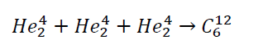

acceleration due to gravity = 9.8 m s^{–2}; speed of sound in air = 343 m s^{–1}

14. Answer any two of the following parts (a), (b), (c), (d).

(a)
- What is meant by displacement?
distance in a given direction.
- The formula s = ut + ½at² is a version of one of the equations describing linear motion.
Explain what each letter stands for in this equation.
s = displacement
u = initial velocity
t = time
a = acceleration
- Derive this equation.
s = (v_{average})(time) But $v_{average=}\frac{u+v}{2}$

Therefore $s=(\frac{u+v}{2})t$ $2s=(u+v)t$

But v = u + at $2s=(u+u+at)t$ $2s=2ut+at^{2}$ $s=ut+\frac{1}{2}at^{2}$

- Describe the assumptions which make this equation valid.
Acceleration is constant throughout.
u and v are instantaneous velocities.
- Calculate the time the stone is in the air.

We can take the upward direction as positive. Displacement and acceleration due to gravity are both downwards so we need to make both of those negative.
s = (ut + ½at²) =
-19 = 6t + ½(-9.8)t² 4.9t² – 6t – 19 = 0

Solve to get t = 2.67 m

(b)
- Define resistance.
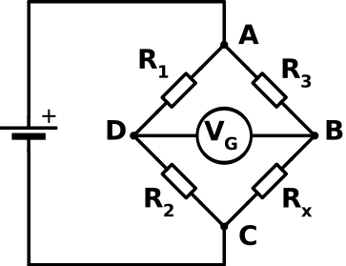
Ratio of potential difference to current

A student set up a Wheatstone bridge to find the resistance of a piece of wire.
A series combination of a 2 Ω resistor and a 3 Ω resistor is put in parallel with another series combination of a variable resistor and the piece of metal wire.
- Draw a circuit diagram of this Wheatstone bridge.
voltage source, 4 resistors, galvanometer, correct arrangement
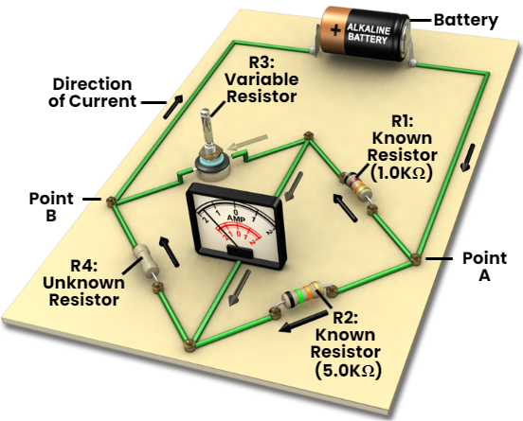
- Describe how the student checked that the Wheatstone bridge was balanced.
galvanometer reads zero
- The Wheatstone bridge was balanced when the variable resistor had a resistance of 5 Ω.
Calculate the resistance of the piece of metal wire.

The formula for a balanced Wheatstone bridge is as follows:
$\frac{R_{1}}{R_{2}}=\frac{R_{3}}{R_{4}}$ ⇒ $\frac{2}{3}=\frac{5}{R_{wire}}$ ⇒ R_{wire} = $\frac{(5)(3)}{2}$ ⇒ R_{wire} = 7.5 Ω
- Apart from measuring resistance, state one other practical use of a Wheatstone bridge.
Temperature control, fail safe device

(c)
- What is the Doppler effect?
It is the apparent change in frequency due to relative motion between the source and the observer
- Describe a laboratory experiment to demonstrate the Doppler effect.
Tie a piece of string to an electric buzzer which is emitting a fixed tone.
Swing it around your head.
An observer will note the frequency increasing and decreasing as the buzzer goes around.

- Calculate the speed of the car.
- Calculate the frequency of the engine sound heard by the driver of the car.

Frequency is observed to be 303 Hz as the car approaches | Frequency is observed to be 272 Hz as the car moves away
$f^{'}$= 303 Hz  c = 343 m s^{–1} $f^{'}=\frac{(f)(c)}{c-u}$  $$303=\frac{(f)(343)}{343-u}$$  $$\left(303\right)\left(343-u\right)=343f$$ | $f^{'}$= 272 Hz  c = 343 m s^{–1} $f^{'}=\frac{(f)(c)}{c+u}$  $$272=\frac{(f)(343)}{343+u}$$  $$\left(272\right)\left(343+u\right)=343f$$
$$\left(303\right)\left(343-u\right)=\left(272\right)\left(343+u\right)$$
$$103929-303u=93296=272u$$
$$10633=575u$$
u = 18.49 m s⁻¹

$$\left(303\right)\left(343-u\right)=343f$$
$$\left(303\right)\left(343-18.49\right)=343f$$
$$\left(303\right)\left(324.51\right)=343f$$
$$\left(98326.53\right)=343f$$
f = 286.7 Hz

(d)
- What is meant by capacitance?
charge // C = q/V
per unit volt // notation
- Describe a laboratory experiment to demonstrate how the capacitance of a parallel‐plate capacitor varies with the distance between the plates.
apparatus/diagram
method
result
- Draw a diagram of the electric field between the plates of a charged parallel‐plate capacitor.
parallel lines
direction indicated
- The keys on some modern keyboards act as parallel‐plate capacitors.
When the key is pressed, the distance between the plates is changed.
A parallel‐plate capacitor has a capacitance of 0.12 pF when the distance between its plates is 5 mm.
Calculate its capacitance when the distance between its plates changes to 0.3 mm.

The distance changed from 5 mm to 0.3 mm so got 16.67 times smaller (or we can say that the distance decreased by a factor of 16.67).
$C=\frac{εA}{d}$ Therefore capacitance is inversely proportional to distance, so if the distance gets 16.67 times smaller the capacitance must get 16.67 times bigger.

C = 0.12 pF = $0.12 pF=0.12{×10}^{-12}$ F

$$C_{new}=\left(0.12{×10}^{-12}\right)\left(6.67\right)=8× {10}^{8} F$$

